DATABASE MANAGEMENT SYSTEM LAB(MINI PROJECT)
INVENTORY MANAGEMENT SYSTEM
Introduction:
Inventory management is an important activity in any retail business. It helps maintain the availability of products, track stock levels, and manage sales efficiently. In grocery shops, manual inventory tracking may lead to errors, stock shortages, or overstocking.
The Inventory Management System for EMart Grocery Shop is a database application designed to manage product details, supplier information, stock availability, and sales transactions. The system stores all the information in a structured database and allows the shop owner to easily monitor inventory and update stock levels automatically after sales.
This system improves efficiency, reduces manual work, and ensures accurate stock management.

Aim:
To develop a GUI-based real-life database application for an Inventory Management System for EMart Grocery Shop and implement database operations such as ER modeling, normalization, views, triggers, functions, stored procedures, and ACID properties.

Objectives
- To design a database for managing grocery shop inventory.
- To build an Entity Relationship (ER) model for the system.
- To apply database normalization techniques.
- To create tables, views, triggers, and functions.
- To implement stored procedures for complex operations.
- To demonstrate ACID properties of transactions.

Problem Description
In small grocery shops, inventory is often managed manually using notebooks or spreadsheets. This approach can cause:
- Incorrect stock records
- Difficulty tracking product sales
- Delay in updating inventory
- Difficulty identifying low stock items
The Inventory Management System solves these problems by storing all data in a structured database and automatically updating stock information after each transaction.

Software Requirements:
- Oracle Database / SQL Developer
- Windows Operating System
- SQL and PL/SQL

6. Entity Relationship (ER) Model
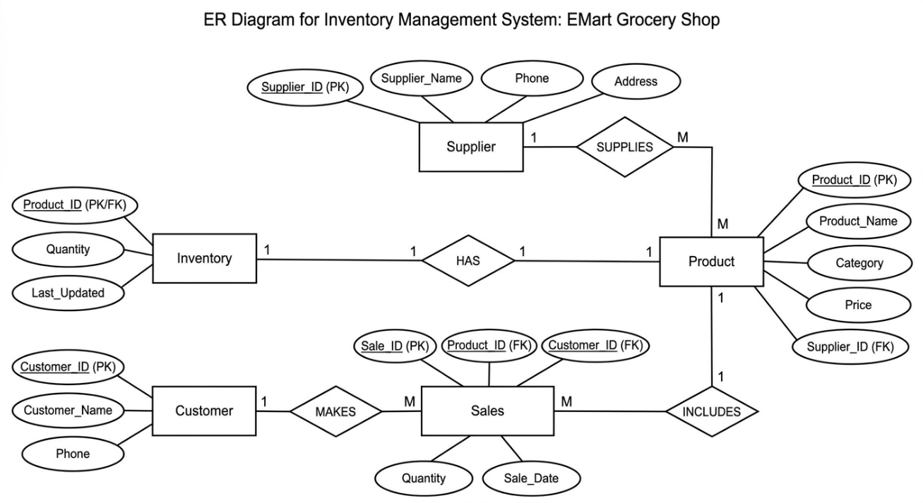

Code:

ALTER SESSION SET CONTAINER = XEPDB1;
CREATE USER inventory IDENTIFIED BY inventory123;
GRANT CONNECT, RESOURCE TO inventory;
ALTER USER inventory
DEFAULT TABLESPACE users
QUOTA UNLIMITED ON users;

SHOW CON_NAME;
##table creation start

CREATE TABLE supplier (
supplier_id NUMBER PRIMARY KEY,
supplier_name VARCHAR2(50),
phone VARCHAR2(15),
address VARCHAR2(100)
);

CREATE TABLE product (
product_id NUMBER PRIMARY KEY,
product_name VARCHAR2(50),
category VARCHAR2(50),
price NUMBER(10,2),
quantity NUMBER,
supplier_id NUMBER,
FOREIGN KEY (supplier_id) REFERENCES supplier(supplier_id)
);

CREATE TABLE customer (
customer_id NUMBER PRIMARY KEY,
customer_name VARCHAR2(50),
phone VARCHAR2(15)
);

CREATE TABLE orders (
order_id NUMBER PRIMARY KEY,
customer_id NUMBER,
order_date DATE,
total_amount NUMBER,
FOREIGN KEY (customer_id) REFERENCES customer(customer_id)
);

CREATE TABLE order_details (
order_detail_id NUMBER PRIMARY KEY,
order_id NUMBER,
product_id NUMBER,
quantity NUMBER,
price NUMBER,
FOREIGN KEY (order_id) REFERENCES orders(order_id),
FOREIGN KEY (product_id) REFERENCES product(product_id)
);

##table creation ends

SELECT table_name FROM user_tables;

show tables;

SELECT table_name
FROM user_tables
WHERE table_name IN (
'SUPPLIER',
'PRODUCT',
'CUSTOMER',
'ORDERS',
'ORDER_DETAILS'
);

INSERT INTO supplier VALUES (1,'ABC Grocery Suppliers','9876543210','Chennai');

INSERT INTO supplier VALUES (2,'Fresh Food Suppliers','9123456780','Coimbatore');
INSERT INTO product VALUES (101,'Rice','Grocery',50,100,1);

INSERT INTO product VALUES (102,'Sugar','Grocery',45,150,1);

INSERT INTO product VALUES (103,'Milk','Dairy',30,200,2);
INSERT INTO customer VALUES (1,'Ravi','9876500001');

INSERT INTO customer VALUES (2,'Priya','9876500002');
INSERT INTO orders VALUES (1,1,SYSDATE,150);

INSERT INTO orders VALUES (2,2,SYSDATE,90);
INSERT INTO order_details VALUES (1,1,101,2,100);

INSERT INTO order_details VALUES (2,2,103,3,90);
COMMIT;
SELECT * FROM supplier;
SELECT * FROM product;
SELECT * FROM customer;
SELECT * FROM orders;
SELECT * FROM order_details;

#creating view
CREATE VIEW product_stock_view AS
SELECT product_name, category, price, quantity
FROM product;

SELECT * FROM product_stock_view;

CREATE VIEW supplier_product_view AS
SELECT s.supplier_name,
p.product_name,
p.price
FROM supplier s
JOIN product p
ON s.supplier_id = p.supplier_id;

SELECT * FROM supplier_product_view;

CREATE VIEW customer_order_view AS
SELECT c.customer_name,
o.order_id,
o.order_date,
o.total_amount
FROM customer c
JOIN orders o
ON c.customer_id = o.customer_id;

SELECT * FROM customer_order_view;

#creating triggers
CREATE TABLE product_audit (
audit_id NUMBER GENERATED ALWAYS AS IDENTITY,
product_id NUMBER,
action_type VARCHAR2(20),
action_date DATE
);

CREATE OR REPLACE TRIGGER product_audit_trigger
AFTER INSERT OR UPDATE OR DELETE ON product
FOR EACH ROW
BEGIN
IF INSERTING THEN
INSERT INTO product_audit(product_id, action_type, action_date)
VALUES(:NEW.product_id,'INSERT',SYSDATE);

ELSIF UPDATING THEN
INSERT INTO product_audit(product_id, action_type, action_date)
VALUES(:NEW.product_id,'UPDATE',SYSDATE);

ELSIF DELETING THEN
INSERT INTO product_audit(product_id, action_type, action_date)
VALUES(:OLD.product_id,'DELETE',SYSDATE);
END IF;
END;
/

INSERT INTO product VALUES (104,'Oil','Grocery',120,50,1);

SELECT * FROM product_audit;

#create stored procedure
CREATE OR REPLACE PROCEDURE add_product(
p_id NUMBER,
p_name VARCHAR2,
p_category VARCHAR2,
p_price NUMBER,
p_quantity NUMBER,
p_supplier NUMBER
)
IS
BEGIN
INSERT INTO product
VALUES(p_id, p_name, p_category, p_price, p_quantity, p_supplier);

COMMIT;
END;
/

EXEC add_product(105,'Tea','Beverage',80,60,1);

SELECT * FROM product;

#testing ACID PROPERTY
#DEMONSTRATE ATOMICITY
SAVEPOINT before_update;

UPDATE product
SET price = 100
WHERE product_id = 101;

SELECT * FROM product WHERE product_id = 101;

ROLLBACK TO before_update;

SELECT * FROM product WHERE product_id = 101;

UPDATE product
SET quantity = quantity - 10
WHERE product_id = 101;

COMMIT;

#DEMONSTRATE CONSISTENCY
UPDATE product
SET quantity = quantity - 10
WHERE product_id = 101;

COMMIT;

#DENMONSTRATE ISOLATION
UPDATE product
SET price = 70
WHERE product_id = 101;

SELECT * FROM product WHERE product_id = 101;

#DEMONSTRATE DURABILITY
UPDATE product
SET price = 75
WHERE product_id = 101;

COMMIT;

ALTER SESSION SET CONTAINER = XEPDB1;
GRANT CREATE SESSION TO inventory;
GRANT CONNECT, RESOURCE TO inventory;
SELECT username FROM dba_users;

SELECT table_name FROM user_tables;

GRANT SELECT, INSERT, UPDATE, DELETE ON system.product TO inventory;
SHOW USER;

